Importing a Resource Mailbox .PST File (Windows)
*Important Notes*
It is recommended that you read this entire document prior to install for understanding/clarity/preparation
- You MUST have the resource mailbox already added in your MS Outlook Client
- If you are remote, you MUST connect to the VPN before beginning this process
- This process will take a long time depending on the size of your resource .PST file and it is recommended that you do this process at the end of your day
- During the install process, your MS Outlook Client will not be operational and will be locked down until the process is complete, however, you can still access and use the Outlook Web App
- This process only needs to be completed once for each resource mailbox and all mail will show up for all those who have access to it

- Copy and paste your Resource Mailbox .PST file from this location HERE to your desktop

- Open Outlook > File > Open & Export > Import/Export
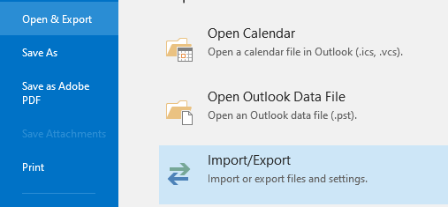
- The default selection of “Import from another program or file” is correct so just click Next
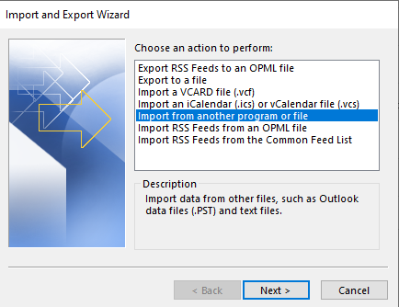

- Select Outlook Data File (.PST) > Next

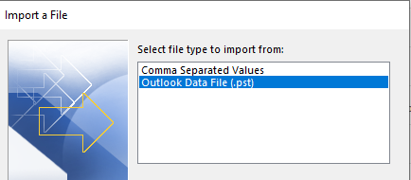

- Click Browse and go to your desktop to find your resource .PST file you copied. Select Next

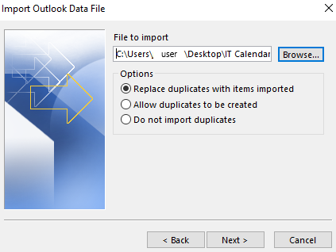

***IMPORTANT NOTE***
This part will take a long time once the import process has started, it is recommended to do this at the end of your day. This is because the MS Outlook Client will not be operational during this time and is basically locked down until the process is complete.

- Make sure the correct Name of your Resource Mailbox is showing in the Import Outlook Data File window like the example below. This ensures that the file gets imported into the correct location.

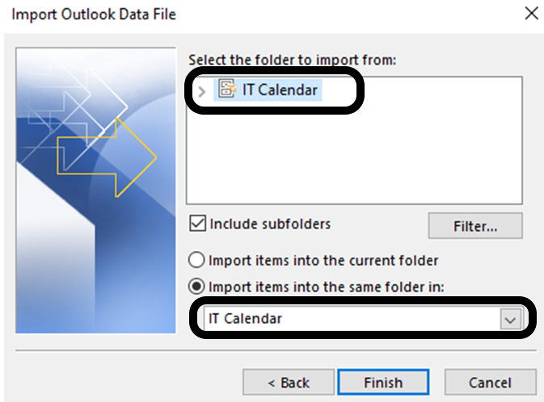

- Click the Finish button to complete the process.

