Migrating your Outlook to the O365 Cloud
Part 1: Connecting your new Office 365 account

We will start by removing the “old” Outlook profile in the Control Panel.

  - On your computer, open the Control Panel by searching for it
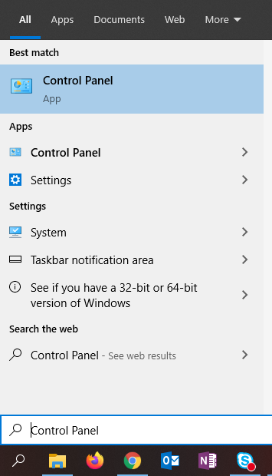

  - Select View by: Large Icons > then select Mail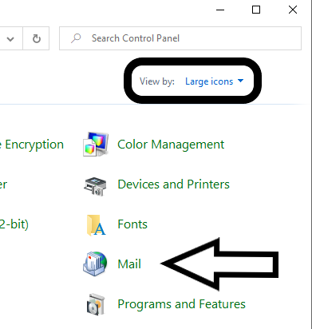

  - Select Show Profiles…
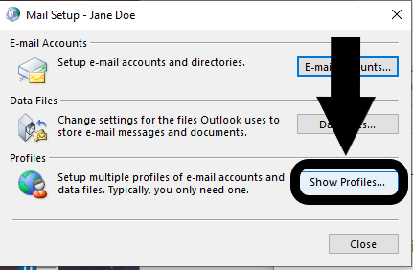

  - Select your mail profile that’s listed > Remove
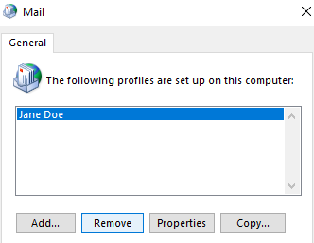

If you see this popup, say YES and proceed to step 5.

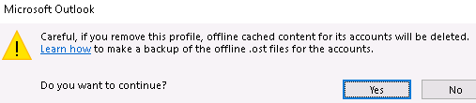

If you are met with this popup, select Use Old Data. If you don’t see this, proceed to step 5.

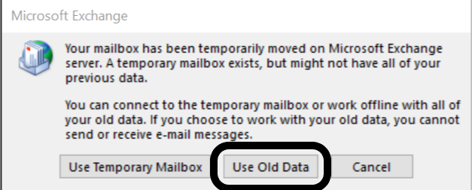

  - Select Add… > Name your new profile anything, I suggest “Cloud” > OK
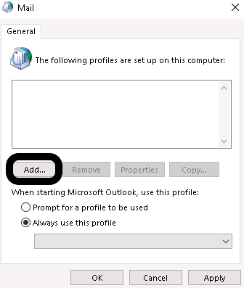

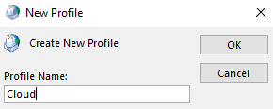

  - At this screen your information will auto-fill > select Next
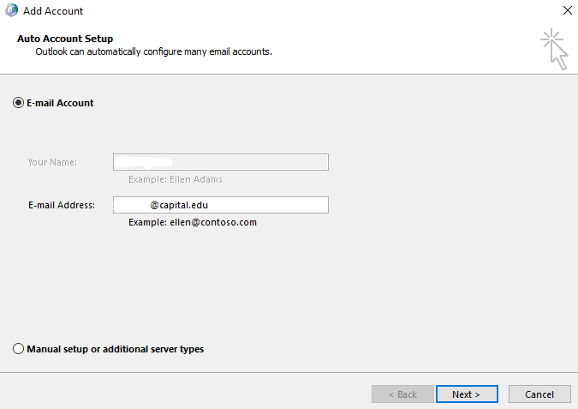

  - You will be at this screen for a very long time depending on how much email your account had contained. Upwards of 20 minutes or more.

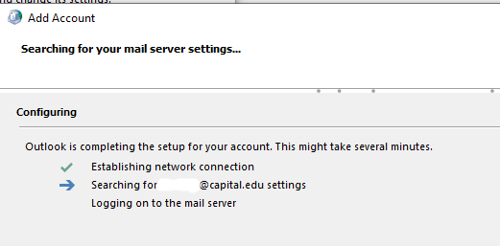

  - It is done when see a Windows login box, enter your password and check the “remember me” box as well. Select finish when done, then OK if the notice popup appears.

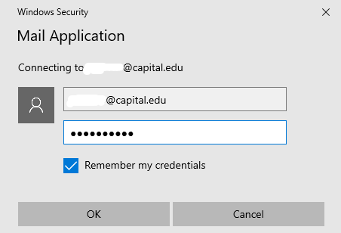

  - Open Outlook to allow it to start downloading all of your current email messages.

In Part 2 we will import your old emails into the cloud!

Migrating your Outlook to the O365 Cloud
Part 2: Importing your old emails
If you are working remote, you will need to connect to the VPN before starting this part.

This part will take a long time once the import process has started, it is recommended to do this at the end of your day. This is also because Outlook will be unusable during this time and is basically locked down until it completes.

If you need to wait to do this later in the day, just do step 1 and 2

- Open File Explorer
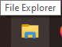
  - Copy and Paste the following link into the address bar at the top and hit Enter
  - Or you may hold down CTRL + Left-Click the link to open it
\\tempserver\OldEmails

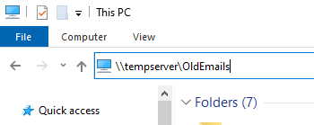

- You will then see a folder with your name on it, open it. Inside it will be your outlook data file with your name on it, copy and paste it to your Desktop

***Remote VPN users***
Once the file is on your desktop, you may disconnect from the VPN
(This will help speed things up later on)

- Open Outlook > File > Open & Export > Import/Export
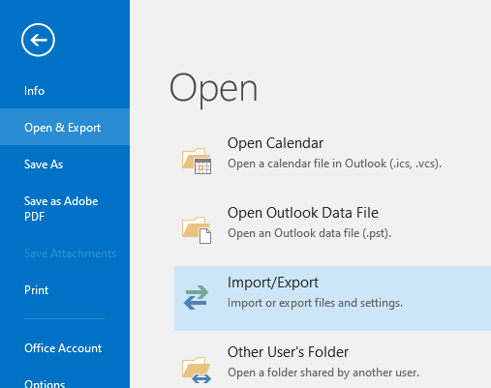

- The default selection is correct so just click Next.
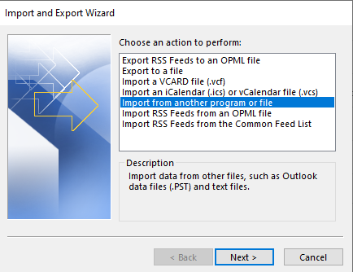

- Select Outlook Data File (.pst) > Next
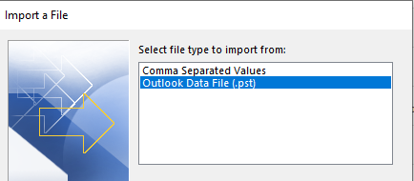

- Browse to your desktop, find your file you copied and select it, Next

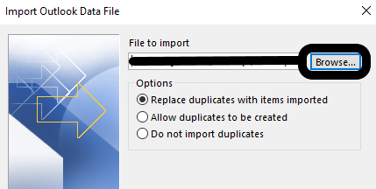

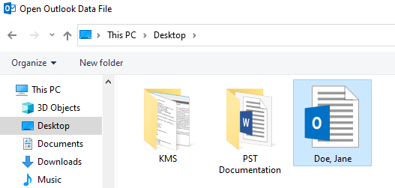

- The default selection is fine, Finish
This process will take a very long time, depending on how much mail you have.
You will also have to close SKYPE before clicking Finish

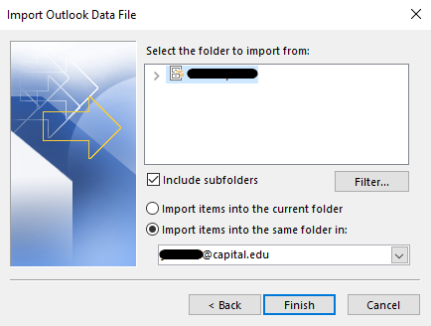

Please Note: Any inbox rules you have created will need to be recreated again

- Once the import process is complete, the last step is to disable Cached Exchange Mode.
    - Open Outlook > File > Account Settings > Account Settings
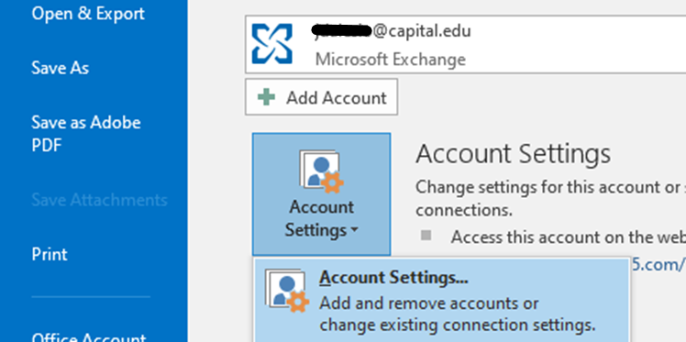

- Select your account > Change…
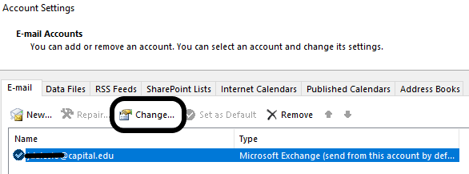

- Uncheck the box > Next > OK > Finish > restart your Outlook
